Excel Part 1

1. What is the difference between 'Paste' and 'Paste Special' in Excel? Briefly explain with examples.

->
Feature | Paste | Paste Special
Purpose | Directly pastes everything copied | Allows you to choose what to paste
Data Included | Values + Formulas + Formatting + Comments, etc. | Specific items like only values, formulas, formatting, transpose, etc.
Flexibility | Simple, no options | Many options, more control over paste

Example 1 — Normal Paste
- You copy a cell A1 with value =B1+C1.
- When you Paste, Excel copies:
  - The formula (=B1+C1)
  - The cell formatting (color, borders)
  - Any comments

Example 2 — Paste Special → Values
- You copy the same cell A1 with formula.
- Use Paste Special Values.
- It pastes only the final number, not the formula.

Example 3 — Paste Special → Transpose
- Copies rows into columns or vice-versa.
- Example: Row data (A1:A3 = 10,20,30)
- Paste Special → Transpose
- It becomes Column data (B1:C3)

2. Describe the functions and usefulness of 'Freeze Panes' and 'Split Panes' in Excel.

-> Freeze Panes
Function
Freeze Panes keeps selected rows or columns visible while you scroll through the rest of the worksheet.
Usefulness
- Helps view headers (like column titles or row names) all the time.
- Best for large datasets where you need to keep track of headings.
Examples
- Freeze Top Row: Header row stays visible when scrolling down.
- Freeze First Column: First column stays visible when scrolling right.
- Freeze Panes (Custom): You can freeze both row(s) above and column(s) left of the selected cell.
  - Example: Select cell B2 → Freeze Panes → Row 1 and Column A will stay visible.
Split Panes
Function
Split Panes divides the worksheet into separate sections (windows) that can be scrolled independently.
Usefulness
- Allows comparing different parts of the same sheet at the same time.
- You can view distant rows/columns together without losing your place.
Examples
- Splitting horizontally creates two scrollable sections (top and bottom).
- Splitting vertically creates left and right scrollable sections.
- Splitting both creates 4 independent panes to view different areas simultaneously

3. Explain the difference between inserting a new row and inserting a new column in Excel. Can you insert multiple rows or columns at once?

->
Action | Insert Row | Insert Column
What it does | Adds a new horizontal line of cells | Adds a new vertical line of cells
Effect on data | Shifts the existing rows down | Shifts the existing columns to the right
Label change | New row gets a new row number | New column gets a new column letter

Example
- If you insert a row above Row 5, the old Row 5 becomes Row 6.
- If you insert a column before Column C, the old Column C becomes Column D.

4. What are logical functions in Excel? Provide examples of at least two logical functions and their applications.

-> Logical functions are used to make decisions in Excel based on conditions.
They check whether a statement is TRUE or FALSE and return results accordingly.
They are very useful for data analysis, filtering, grading, discount calculation, etc.

Examples of Logical Functions
1️⃣ IF Function
- Checks a condition and returns one value if it is TRUE, and another if it is FALSE.
Syntax:
=IF(condition, value_if_true, value_if_false)
Example Application:
To check whether a student passed:
=IF(A2 >= 40, "Pass", "Fail")

AND Function
- Returns TRUE only if all conditions are true.
Syntax:
=AND(condition1, condition2, ...)
Example Application:
To check eligibility — a candidate must score more than 50 in Maths and Science:

=AND(B2 > 50, C2 > 50)

5. Discuss the purpose of 'XLOOKUP' and how it differs from the traditional 'VLOOKUP' function.

-> XLOOKUP is a modern lookup function used to search for a value in a range and return a matching result from another range.
It is more powerful, flexible, and easier to use than older lookup functions.
Feature | VLOOKUP | XLOOKUP
Search direction | Can only search left → right | Can search any direction (left, right, up, down)
Column reference | Requires column index number | Directly select the return array, no index needed
Exact match | Default is approximate match | Default is exact match
Data change sensitivity | Breaks if columns are inserted/deleted | Does not break when structure changes
Error handling | Needs extra formula to manage errors | Built-in IF-NOT-FOUND argument
Range lookup | Only vertical lookup | Supports vertical and horizontal lookup

6. Create a worksheet titled 'Employee Data' with columns: Name, Age, Department. Add 5 rows of data. Format as follows:
● Bold and center-align the header row
● Apply a fill color
● Auto-fit column width

-> 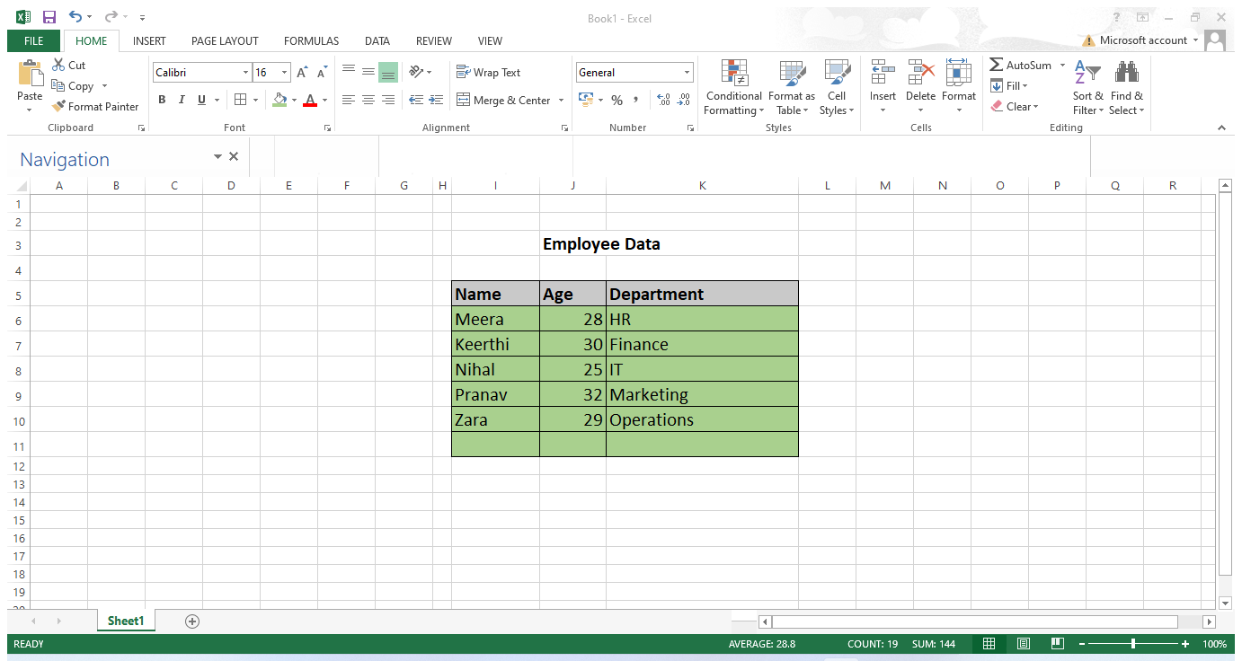

7. Demonstrate how to insert and delete multiple rows and columns in Excel.

-> Before inserting Rows and Columns

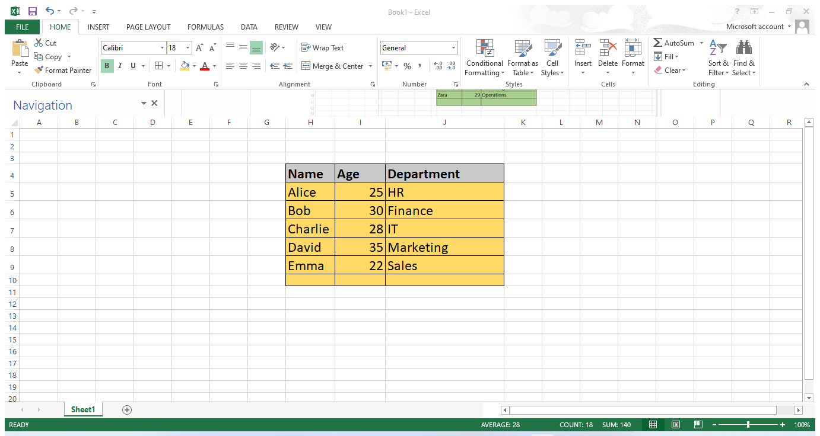
After inserting Rows & Columns

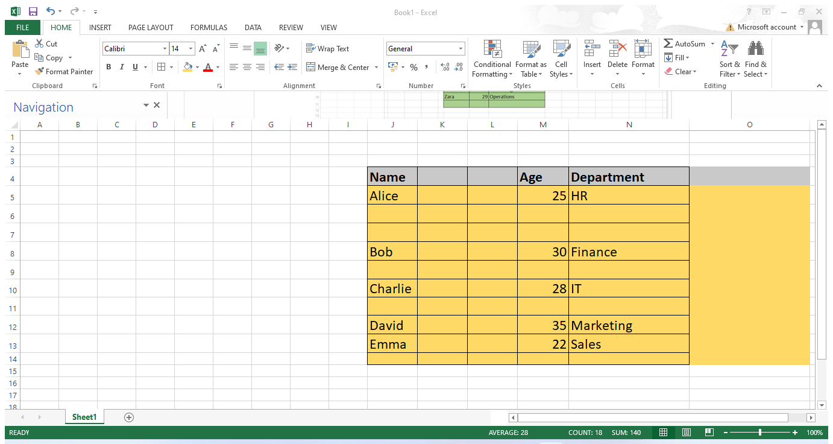

Before Deleting Rows & Columns
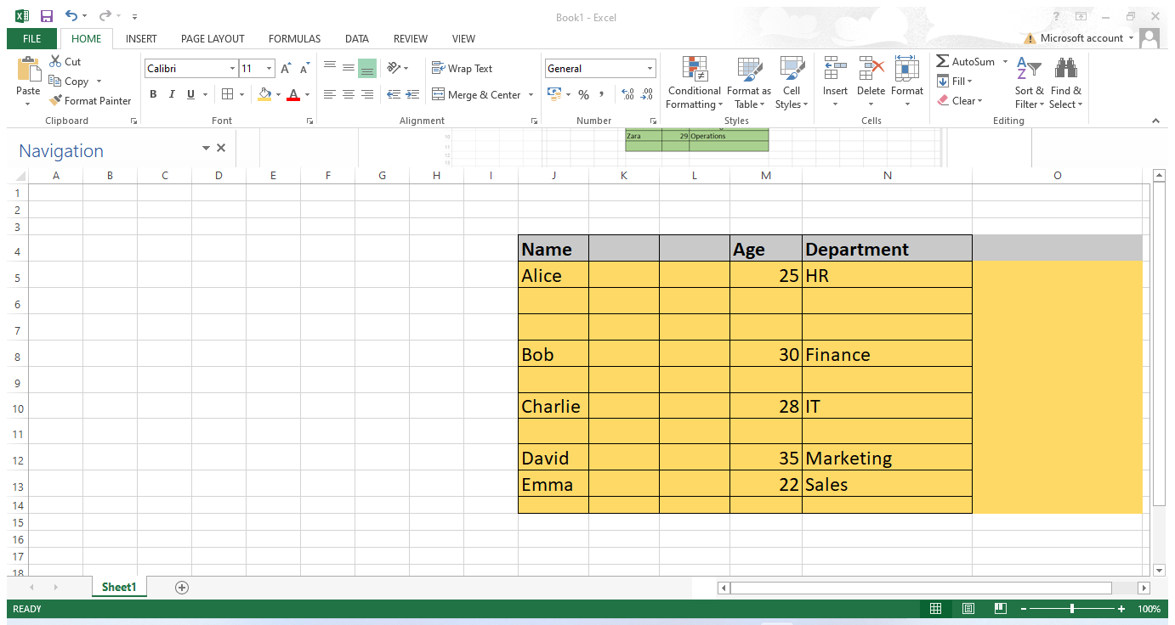

After Deleting Rows & Columns
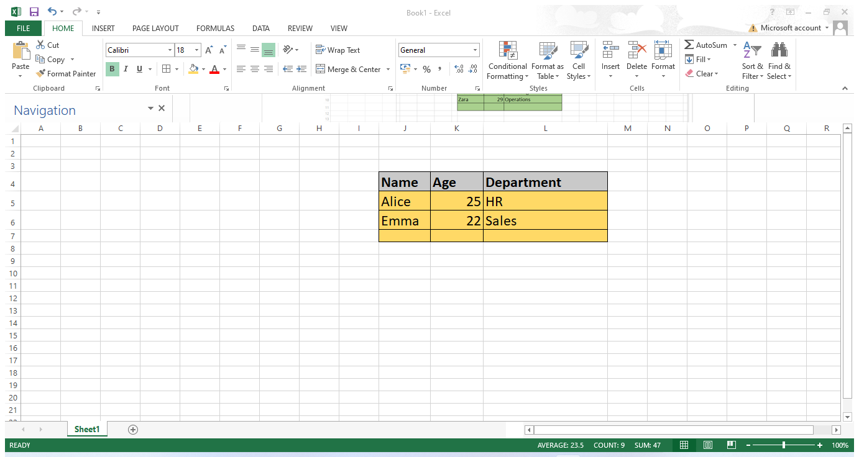

8. Use Excel's 'Find and Replace' feature to update department names in a sample table.

-> 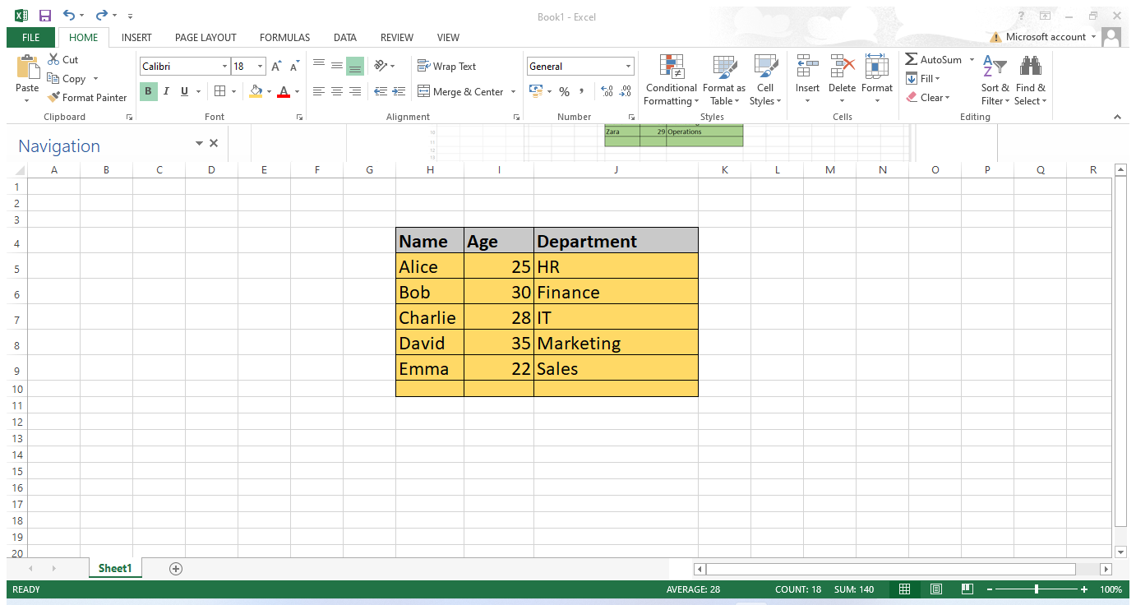

After Replace
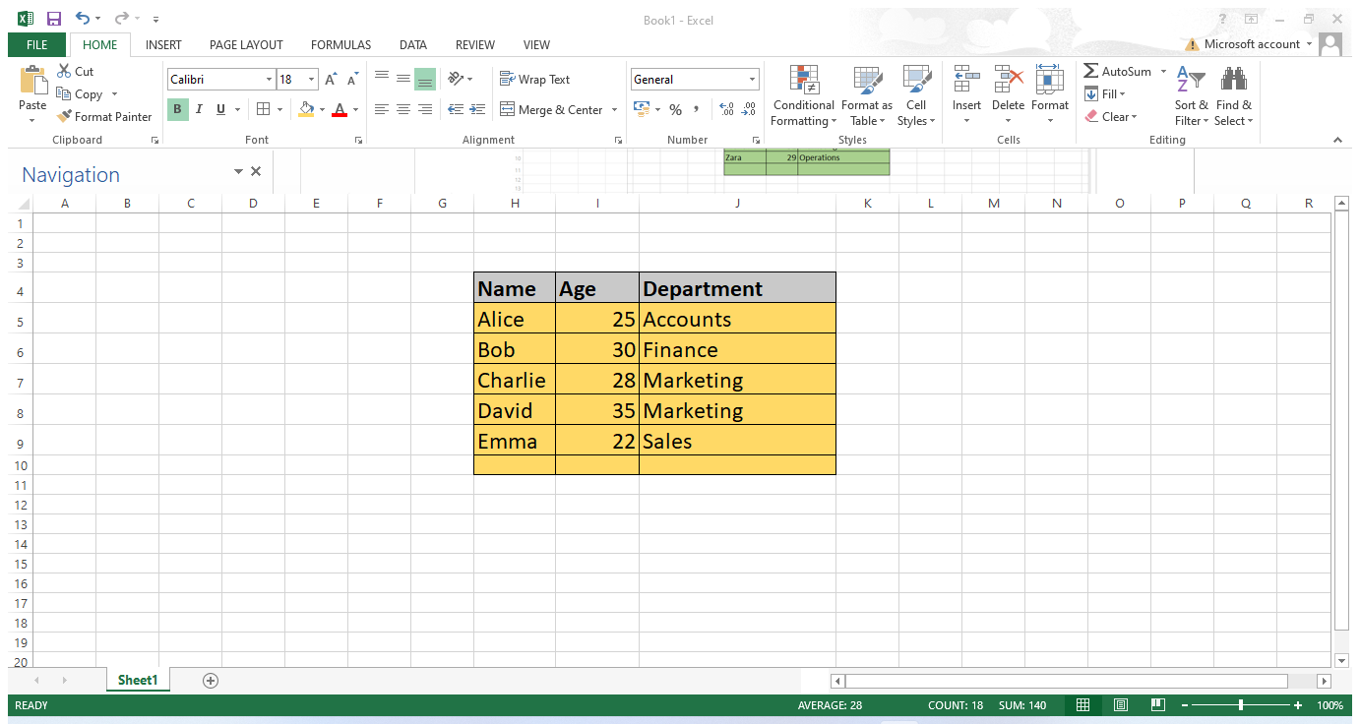

9. Create a small numerical dataset and apply the following functions:
● AVERAGE
● MAX
● MIN

->

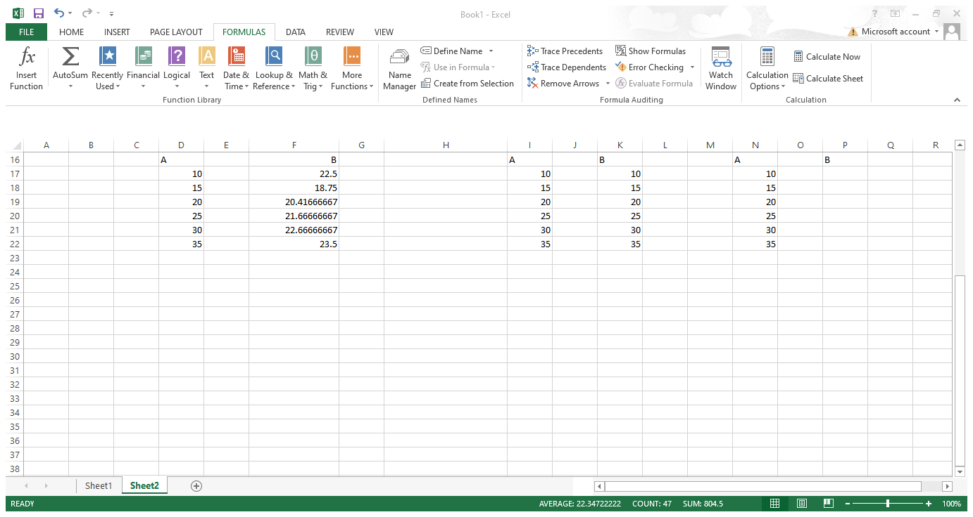

10. You're working with a dataset that contains missing values. As a Data Scientist, explain how you'd detect and handle missing data using Excel. Mention tools like:
● Go To Special
● ISBLANK
● COUNTBLANK

Go to Special

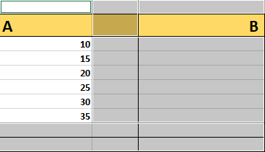

ISBLANK
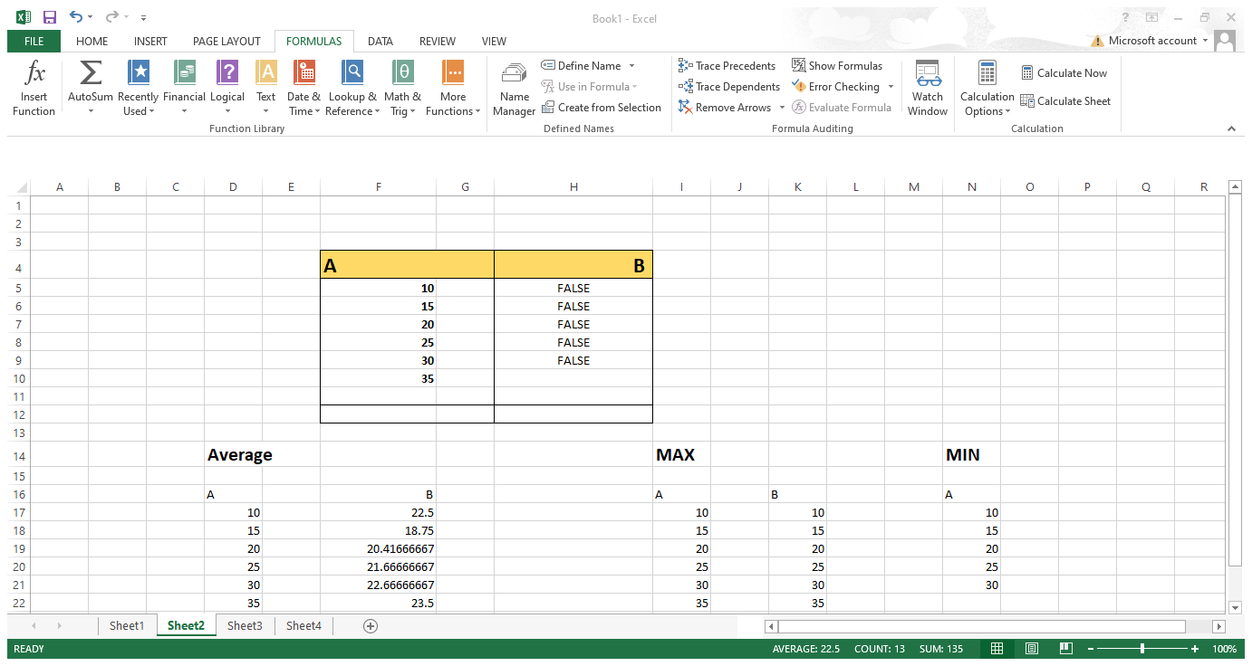

COUNTBLANK

